**Abstract**

The applications of machine learning have now reached variety of industries, including banking and financial organizations. While credit approval is a key concern of the banking industry, machine learning is widely regarded as one of the most effective methods for credit approval. In the banking sector, every banking infrastructure contains an enormous dataset for customers’ credit card approval which requires customer profiling. The customer profiling means collection of data related to what customers need. It depends on customers’ basic information like field of work, address proof, credit score, salary details, etc. This process mainly concentrates on predicting approval of credit cards to customers using machine learning. Machine Learning is the scientific study of algorithms and statistical models that computers use to perform specific tasks without any external instructions or interference. In the current trend this process is possible using many algorithms like “K-Mean, Improved K-Mean and Fuzzy C-Means”. This helps banks to have a high profitability to satisfy their customers. However, the currently prevailing system shows an accuracy percentage of about 98.08%. The proposed system aims at improvising the accuracy ratio while using only few algorithms. Machine learning techniques Provide better result for prediction by con- structing models from datasets collected from patients. In this work we will use Machine Learning Classification and ensemble techniques on a dataset to predict credit card approval. The accuracy is different for every model when compared to other models. The Project work gives the accurate or higher accuracy model shows that the model is capable of predicting credit card approval effectively.

**INTRODUCTION**

The growth of the internet has led to a significant rise in credit card usage. It is one of the most used payment methods these days. As the world economy increases, credit card fraud also increasing at an alarming rate. It is also evident that credit card defaulters have also increased significantly. Consequently, the credit card issuing institutions are becoming meticulous in approving credit cards to customers. In addition, the downturn of financial institutions in the USA and Europe during the US subprime mortgage and the European sovereign crisis has raised concerns about risk management properly. Hence, these challenges have attracted significant attention from researchers and practitioners. A wide range of statistical and machine learning techniques have been developed to solve credit card related problems. It is found that machine learning techniques are superior to other traditional statistical techniques in dealing with credit scoring. Machine Learning (ML) means a detailed study of algorithms and scientific models in a scientific manner. This ML is used by computer systems in order to perform a specific task without using outside instructions or explicit instructions. It relies on patterns and inference. Machine Learning is a subset of Artificial Intelligence (AI) which provides systems the capability to learn automatically and improve from experience without any explicit instruction. It gives importance for developing computer programs which can access data and use those data to learn for themselves. Real Life Examples include image recognition, speech recognition, medical diagnosis, prediction, financial services, etc. There are different types of learning in machine learning. They are: o Supervised Learning o Unsupervised Learning o Reinforcement Learning Supervised Learning means providing a full set of data collected from various sources while training an algorithm. Unsupervised Learning means providing the machine with a trained dataset without a specific needed outcome or any explicit instructions. Reinforcement Learning means providing the machine with a game like situation. The system puts forward trial and error to come up with a solution to the problem.

**EXISTING SYSTEM**

Credit card has evolved to a great level in banking industry. Each banking system consists of an enormous number of datasets to carry customer's transactions of their credit cards. So, banks would be in need of customer profiling. Customer Profiling in banks cognizes the issuer's decisions about whom to give banking facilities and what credit limit to be provided. It also helps the issuers to have a better understanding over their potential and current customers. In previous researches, profiling mainly depended on transaction data or demographic data, but in this research, both transaction and demographic data are merged in order to get more accurate results and minimize the possibility of risk occurrence. By using the best techniques, it leads to improvement in accuracy and helps banks to have high profitability through customer satisfaction by focusing on the valuable customer (companies) which are considered as the main engine in the bank's profitability. This study used k-mean, improved k-mean, fuzzy c-means and neural networks. The used dataset is labeled and for neural network classification creating a new label as a target becomes the main aspect of this study, which helps to reduce the execution time of clustering process and provide the best results with accuracy. Finally, by comparing the accuracy ratio the results show that the neural network is the best clustering technique which could give an accuracy percentage of about 98.08%.

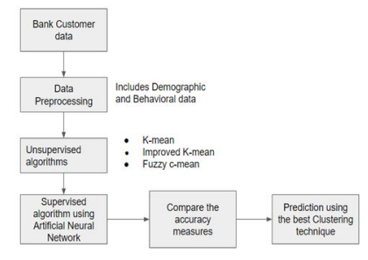

Architecture of the existing system

Initially, the customer data is collected from a reliable source. In the existing system, the dataset was collected from the archive of the University of California, Irvine. The dataset contains about 23 variables and there are no missing data in it. Then these data are preprocessed where both demographic and behavioral or the data used for transactions are considered. Then these data are trained using unsupervised algorithms namely k-mean, improved k-mean and fuzzy c-mean where each algorithms trains data in the form of customer segments. Then, again these data are trained using supervised technique namely artificial neural network. Finally, the results from all the algorithms are considered and compared and the prediction occurs using the best clustering technique. The results showed that the artificial neural network showed the highest accuracy than the other unsupervised algorithms by creating a new label target for the dataset. The drawback is that the effectiveness and performance of this approach are yet to be improved by incorporating some deep learning algorithms especially in the field of medical informatics.

**PROPOSED SYSTEM**

The proposed work aims at improving the current technology using algorithms like decision tree algorithm and k nearest neighbor algorithm. The proposed system is about the maintenance and analysis of customer profiles to approve credit cards. This process happens in an automated process. Automated process means it involves the assistance of machine learning. By manually collecting large sets of data from various customers who are working in various fields and already having credit cards, these data are taken into account and trained and tested in the machine. The trained and tested data are initially separated randomly through algorithms. It is then implemented using python programming language with the help of anaconda tool. The text editor used is Jupyter notebook. After all the trainings and testings of data, the machine will predict whatever data it is being presented at that time, based on customers’ credit score, it will predict whether credit cards can be approved or not. These predictions happen through two algorithms namely: (i) Decision Tree algorithm (ii) Random Forest algorithm (iii) Logistic Regression

**Problem Objective**

The Main Objective of Developing this project is:

Predict whether a person should be approved for giving credit card or not. This is a binary outcome.

* Positive (+) = 1, Person should not be approved for having Credit Card.
* Negative (-) = 0, Person should be approved.
* Experiment with various Classification Models & see which yields greatest accuracy.
* Examine trends & correlations within our data
* Determine which features are most important to Positive/Negative

Credit card approval.

1. To Implement machine learning model to predict future possibility of Credit card fraudsters misusing credit cards given.
2. To determine significant risk factors based on dataset which may give useful insights regarding people applying for credit cards.
3. To analyze feature selection methods and understand their working principle.

**Machine Learning Workflow Undertaken:**

We can define the machine learning workflow in 5 stages.

1. Gathering data
2. Data pre-processing
3. Researching the model that will be best for the type of data
4. Training and testing the model

5. Evaluation

**What is the machine learning model?**

The machine learning model is nothing but a piece of code; which an engineer or data scientist models by training it with the data according to the need of the project and making the model learn through the data and allowing it to predict or give the solution that we want whenever we ask it to give. So, whenever we give our model the new data which we want it to predict, we will get the predicted value according to the model training, the trained model might or might not perform well on the test data that we want it to predict, due to various reasons, so before trying to train any model we need to make sure that the algorithm that is going to use is appropriate for the desired class that we want to predict and based on the data that we are using.

**1. Gathering Data**

The process of gathering data depends on the type of project we desire to make, if we want to make an ML project that uses real-time data, then we can build an IoT system that uses different sensors data. Then the sensor data can be connected to the database where we want to store it. But the collected data cannot be used directly for performing the analysis, Since the collected data might be very irrelevant, extremely large values, unorganized text data, or noisy data to the project that we are working on. Therefore, to solve this problem Data Preparation is done meaning data cleaning.

# 2. Data pre-processing

Data pre-processing is one of the most important steps in machine learning. It is the most important step that helps us to provide accurate and cleaned data for training so that we can get accurate results. In machine learning, there is an 80/20 rule, where, every data scientist should spend his/her 80% time for data pre-processing and 20% time to perform the analysis and build the actual machine learning model.

**What is data pre-processing?**

Data pre-processing is a process of cleaning the raw data and making it a meaningful and understandable format. i.e., the data which is collected in the real world is not clean and consists of a lot of irrelevant data and inconsistent data, so we first convert our raw into a meaningful way to generate an efficient machine learning model pipeline. In other words, whenever the data is gathered from different

sources it is collected in a raw format and this data isn’t feasible for the analysis.  
Therefore, certain steps are executed to convert the data into a small clean, and meaningful way, where our model can understand. This part of the process is called data pre-processing.

## **Why do we need it?**

As we know that data pre-processing is a process of cleaning the raw data into clean data so that it can be used to train the model. So, data pre-processing is an essential step to generate a machine learning model to help us predict, classify, forecast the data when we pass unknown data.

Below mentioned are some of the examples which mostly occur in raw data, when the data is collected.

1. **Missing data:** Missing data/ missing values are the empty spaces in our data that might have occurred due to various reasons, such as Structured missing values, missing completely at random, Missing at Random, missing not at random, each has its method of treating missing values and in the case of Sensor data, missing values might be high due to technical issues, electricity or other environmental factors.

2. **Noisy data:** This type of data is also called outliers; this can occur due to human errors (humans manually gathering the data) or some technical problem of the device at the time of collection of data. Outliers can be easily termed as extremely low values or extremely high values which are not related to the particular data variable.

3. **Inconsistent data:** This type of data error might mostly happen due to human errors (mistakes with the name or values) or duplication of data. Inconsistent in numbering formats or if the data variable is not consistent through all the rows, then we can term it as an inconsistent data variable, making a data variable consistent is very important since it might result in a certain type of bias when the model is trained and it might also result in inaccurate analysis results when we visualize them onto plots.

## Three Types of Data

1. Numeric e.g., Income, Age

2. Categorical e.g., Gender, Nationality

3. Ordinal e.g., Low/Medium/High, Education, Ranking

## How can data pre-processing be performed?

These are a lot of techniques that one can incur to pre-process the data to convert it from raw to a meaningful and understandable format.

1. **Conversion of data:** As we know Machine Learning models can only handle numeric features, hence categorical and ordinal data must be somehow converted into numeric features, we have a lot of transformation functions that we can use on our categorical/ string data type to convert it to numerical formats, such as 1. One Hot Encoding, 2. get dummies (), map ().

2. **Ignoring the missing values:** Whenever we encounter any missing values in our dataset it depends on the developer working on the project whether to delete the missing values or to impute some other values such as, mean, median, Predicting the missing value, or many other techniques.

3. **Filling the missing values:** The process of deleting the missing values can sometimes be efficient only if the missing values are a handful if the missing values are very large then in this case, we might also check the importance of the variables to our model and we can then delete the entire column with the most number of missing values, or we can impute some other value in place of missing value, by further analysis the dataset or by using statistical measurements, or by using some predicting algorithms to predict the missing values.

4. **Outlier’s detection:** As we have already seen, Outliers can be easily termed as extremely low values or extremely high values which are not related to the particular data variable. These are the error values are present in our data set that deviates drastically from other observations in a data set. [Example: human weight = 800 Kg; due to mistyping of extra 0, the entire value is changed, so this can be treated as an outlier, but in reality, outliers can be identified either by using plots or by statistical analysis.]

So, our main goal should be to train the best performing machine learning model nearly accurately using the cleaned/pre-processed data, so that it can help us to give the solutions whenever something new data is passed onto it related to the data that we have trained.

Note: The better your data is, the better the results will be.

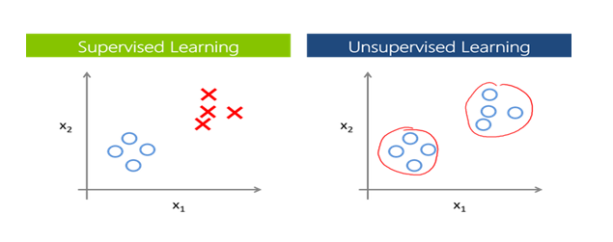

## **Supervised Learning:**

Supervised learning is a branch of machine learning where for each row in the dataset, each row is tagged with a particular label known as the target class.

Supervised Learning is categorized into 2 other categories which are “**Classification**” and “**Regression**”.

## Classification:

**The classification**problem is when the target variable is **categorical**(i.e., the output variable consists of classes such as —Class A or B or something else, there might be 2 classes or more than 2 classes.).

A classification problem can be described as a problem where the target class in a dataset consists of categories, such as “Yes” or “No”, or “spam” or “not spam”.

Widely used Classification algorithms:

* **K-Nearest Neighbour**
* **Naive Bayes**
* **Decision Trees/Random Forest**
* **Support Vector Machine**
* **Logistic Regression**

## Regression:

While a **Regression**problem is when the target variable is **continuous**(i.e., the output is numeric), Regression problem can be easily termed as the problem where we have to forecast about the future or what we do not know right now, it can be anything (Example: House Price Prediction, Stock market trends)

Widely used Regression Algorithms:

* **Linear Regression**
* **Support Vector Regression**
* **Decision Trees/Random Forest**
* **Gaussian Progresses Regression**
* **Ensemble Methods**

## Unsupervised Learning:

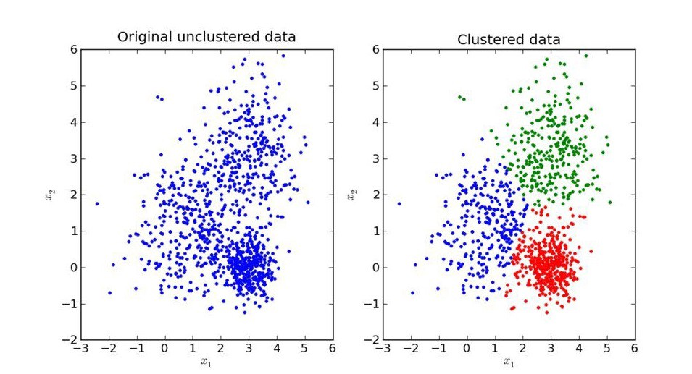 Unsupervised Learning is another branch of Machine Learning where we won’t be having any labels for each row of our data unlike supervised learning, so in this case, the model will try to segregate things based on the features and the data available. In simple terms it segregates the data in terms of clusters, the most important thing in unsupervised learning is the curse of finding the optimal k value (the number of clusters we would like to make).

Similar to Supervised, Unsupervised learning can also be categorized into 2 other categories as “**Clustering**” and “**Association**”.

## Clustering:

Clustering is a process of learning to assign labels to examples by leveraging an unlabelled dataset, Because the dataset is completely unlabeled, deciding on whether the learned model is optimal is much more complicated than in supervised learning.

Clustering Algorithms available:

* **DBSCAN**
* **HDBSCAN**
* **K-Means Clustering**
* **Hierarchical Clustering**
* **Gaussian Mixtures**
* **Spectral Clustering**

## Overview of models under categories:

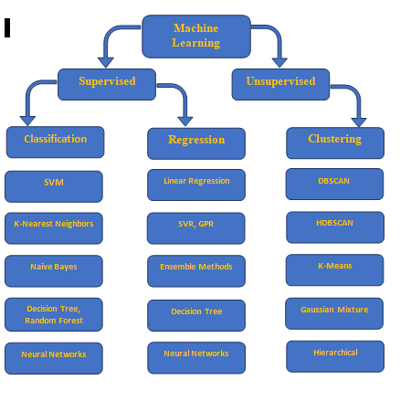

# 4. Training and Testing the model.

Before building any machine learning Project, training is the most important part, where we train our model using the data available and make the machine learn and understand the data, after which when the model has learned from the data, we provide the model with another dataset to evaluate how good our model is performing, if it is performing well, we then test the model using test data, where we get to know the final performance of our model, which can be measure using various metrics, such as Accuracy, recall, precision, and through classification report.

This whole process of building and deploying a model is done using 3 different datasets which are split using train_test_split (), which are ‘**Training data**’, ‘**Validation data**’, and ‘**Testing data**’.

First, we train our classifier/regressor model using ‘**training data set**’, we then tune the parameters, to make the model more efficient ad accurate using ‘**validation set**’, and then we test the performance of our classifier on unseen data/ ‘**test data set**’ which should not be or by any means should be used for training or validating, if we use the same data for testing purpose, our model might perform well, but it will lead to overfitting. The test set will only be available during testing the classifier.

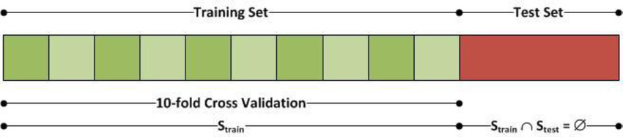

**Training set:** The training set is like a learning material which we give our model to learn so that it understands the data and applies what is understood to the data which we then use that trained model to predict the values with the new data. Training a machine learning model can be done using various algorithms, where the algorithms need to be selected carefully according to the problem that we are trying to solve.

**Validation set:** Cross-validation/ Validation Set is primarily used for estimating how good our model is performing on unseen. Based on the validation data, we can then tune our parameters to make the model more efficient and reliable for deployment.

**Test set:** Test Dataset is simply an unknown dataset, related to the original data which we split at the start so that the model is not aware of the values present in the dataset. The Test dataset is used for assessing the final performance of the model and how well the model is performing.

**Simple Example of Train, Test, Validation Splits.**

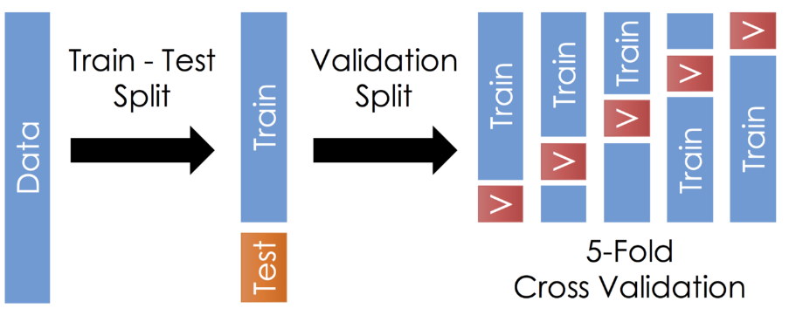

Once the model is trained by the required parameters and achieved a good accuracy score, we can then use the trained model for predicting our test data/unseen data. Once this is done, we can evaluate our model or plot the evaluation metrics of our model performance using **Classification report, Confusion Matrix**, **AUC_ROC** Curve, etc.

**Confusion Matrix**

A confusion matrix is simply an evaluation metric matrix especially used for analyzing the behavior of the model and estimating how good the model is performing. It has 4 parameters, which are ‘**True positives’**,**‘True Negatives’**,**‘False Positives,** and ‘**False Negative’**. Which again derived into various formulas such as TPR, FPR, which helps us to get further performance analysis. Below mentioned is an ideal Confusion Matrix, In Confusion matrix the more the TP and Tn the better the model is, although depending on the project we are working on, we might care about FN and FP, when reducing the number of FP and FN, might become an important step during model evaluation. 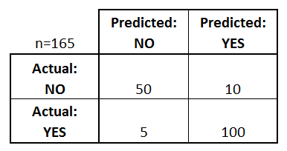

* **True positives:** Both Predicted and Actual value is True.
* **True negatives:** Both Predicted and Actual Value is False.
* **False positives:** In this case, the actual value is False, but the model has predicted True.
* **False negatives: In this case, the actual value is True, but the model has predicted False.**
* Using The TP, TN, FP, FN we can derive some formulas such as:
* *Accuracy = (True Positives +True Negatives) / (Total number of classes)*
* i.e., for the above example:
* Accuracy = (100 + 50) / 165 = 0.9090 (90.9% accuracy)
* Similarly, we can do it for Recall, Precision etc.

## 5. Evaluation

* Model Evaluation is an integral part of the model development process. It helps us to find the best model that represents our data and it will help us to determine the best parameters which are used to fine-tune the model. This Evaluation step will help us determine the best model out of many models that we create.

**METHODOLOGIES**

**Dataset’s descriptions**:

* Training Data.csv
* Test Data.csv

Dataset consists of 13 attributes with,

* + ID – Unique id of each user
  + Income – Income a person is earning.
  + Age – age of a person
  + Experience – persons work experience
  + Married – whether a person is married or not (1-married, 0-not married)
  + House_owner - whether a person owns a house or not.
  + Car_owner – whether a person owns car or not.
  + Profession – which work/profession the person is in right now.
  + City – city the person lives.
  + State – state the person lives.
  + Current_job_years – How many years have been passed working in that profession by a person?
  + Current_house_years – How many years have been passed the person has bought a house?
  + Approval – whether a person should be given approval or not.

**Project Outcomes**

* The main purpose of designing this system is to predict approval of credit card. we have used Various Machine Learning algorithms to evaluate and train the model, such as Logistic Regression, Decision Tree Classifier, Random Forest Classifier. These algorithms are discussed below in detail.

1. **Logistic Regression**: Logistic Regression is a supervised classification algorithm. It is a predictive analysis algorithm based on the concept of probability. Logistic Regression relies highly on the proper presentation of data. So, to make the model more powerful, important features from the available data set are selected using Backward elimination and recursive elimination techniques. This type of statistical analysis (also known as logit model) is often used for predictive analytics and modelling, and extends to applications in machine learning. In this analytics approach, the dependent variable is finite or categorical: either A or B (binary regression) or a range of finite options A, B, C or D (multinomial regression). It is used in statistical software to understand the relationship between the dependent variable and one or more independent variables by estimating probabilities using a logistic regression equation. This type of analysis can help you predict the likelihood of an event happening or a choice being made. For example, you may want to know the likelihood of a visitor choosing an offer made on your website — or not (dependent variable). Your analysis can look at known characteristics of visitors, such as sites they came from, repeat visits to your site, behaviour on your site (independent variables). Logistic regression models help you determine a probability of what type of visitors are likely to accept the offer — or not. As a result, you can make better decisions about promoting your offer or make decisions about the offer itself.

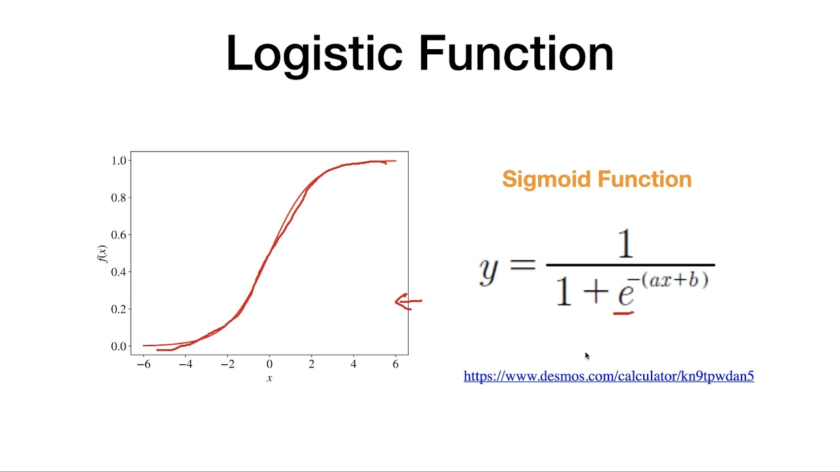

1. **Random Forest Classifier**: Random Forest is a supervised machine learning algorithm. This Technique can be used for both regression and classification tasks but generally performs better in classification tasks. As the name suggests, Random Forest technique considers multiple decision trees before giving an output. So, it is basically an ensemble of decision trees. This technique is based on the belief that a greater number of trees would converge to the right decision. For classification, it uses a voting system and then decides the class whereas in regression it takes the mean of all the outputs of each of the decision trees. It works well with large datasets with high dimensionality. The random forest algorithm is an extension of the bagging method as it utilizes both bagging and feature randomness to create an uncorrelated forest of decision trees. Feature randomness, also known as feature bagging or “[the random subspace method](https://www.stat.berkeley.edu/~breiman/randomforest2001.pdf)”(link resides outside IBM) (PDF, 121 KB), generates a random subset of features, which ensures low correlation among decision trees. This is a key difference between decision trees and random forests. While decision trees consider all the possible feature splits, random forests only select a subset of those features. If we go back to the “should I surf?” example, the questions that I may ask to determine the prediction may not be as comprehensive as someone else’s set of questions. By accounting for all the potential variability in the data, we can reduce the risk of overfitting, bias, and overall variance, resulting in more precise predictions.

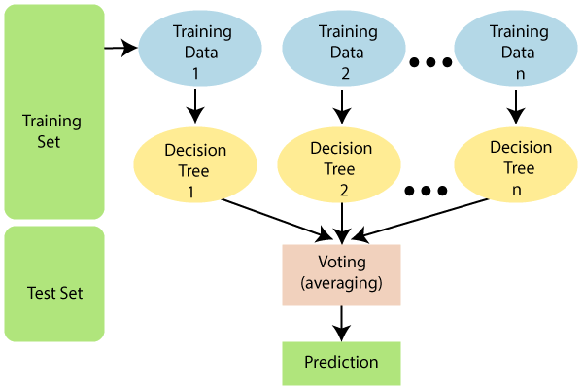

1. **Decision Tree:** A decision tree is a [decision support](https://en.wikipedia.org/wiki/Decision_support_system) tool that uses a [tree-like](https://en.wikipedia.org/wiki/Tree_(graph_theory)) [model](https://en.wikipedia.org/wiki/Causal_model) of decisions and their possible consequences, including [chance](https://en.wikipedia.org/wiki/Probability) event outcomes, resource costs, and [utility](https://en.wikipedia.org/wiki/Utility). It is one way to display an [algorithm](https://en.wikipedia.org/wiki/Algorithm) that only contains conditional control statements. Decision trees are commonly used in [operations research](https://en.wikipedia.org/wiki/Operations_research), specifically in [decision analysis](https://en.wikipedia.org/wiki/Decision_analysis), to help identify a strategy most likely to reach a [goal](https://en.wikipedia.org/wiki/Goal), but are also a popular tool in [machine learning](https://en.wikipedia.org/wiki/Decision_tree_learning). A decision tree is a [flowchart](https://en.wikipedia.org/wiki/Flowchart)-like structure in which each internal node represents a "test" on an attribute (e.g. whether a coin flip comes up heads or tails), each branch represents the outcome of the test, and each leaf node represents a class label (decision taken after computing all attributes). The paths from root to leaf represent classification rules. In [decision analysis](https://en.wikipedia.org/wiki/Decision_analysis), a decision tree and the closely related [influence diagram](https://en.wikipedia.org/wiki/Influence_diagram) are used as a visual and analytical decision support tool, where the [expected values](https://en.wikipedia.org/wiki/Expected_value) (or [expected utility](https://en.wikipedia.org/wiki/Expected_utility)) of competing alternatives are calculated.

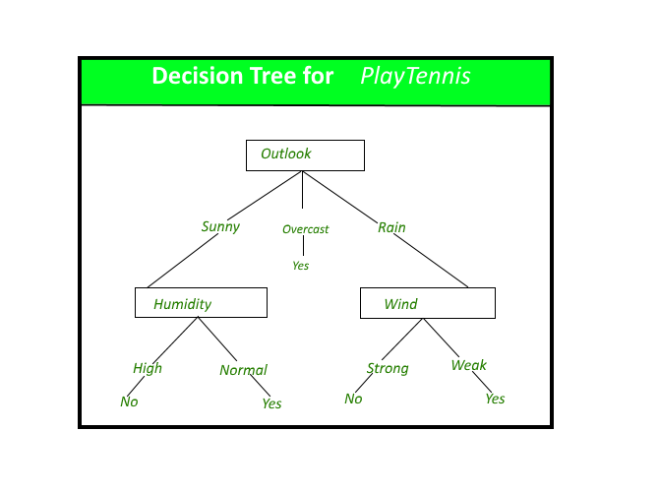

A decision tree consists of three types of nodes

1. Decision nodes – typically represented by squares
2. Chance nodes – typically represented by circles
3. End nodes – typically represented by triangles

Decision trees are commonly used in [operations research](https://en.wikipedia.org/wiki/Operations_research) and [operations management](https://en.wikipedia.org/wiki/Operations_management). If, in practice, decisions have to be taken online with no recall under incomplete knowledge, a decision tree should be paralleled by a [probability](https://en.wikipedia.org/wiki/Probability) model as a best choice model or online selection model [algorithm](https://en.wikipedia.org/wiki/Algorithm). Another use of decision trees is as a descriptive means for calculating [conditional probabilities](https://en.wikipedia.org/wiki/Conditional_probability). Decision trees, [influence diagrams](https://en.wikipedia.org/wiki/Influence_diagrams), [utility functions](https://en.wikipedia.org/wiki/Utility_function), and other [decision analysis](https://en.wikipedia.org/wiki/Decision_analysis) tools and methods are taught to undergraduate students in schools of business, health economics, and public health, and are examples of operations research or [management science](https://en.wikipedia.org/wiki/Management_science) methods.

**Architectural Design**

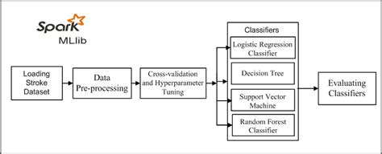

**Flow Chart**

**Testing Dataset**

**Training Dataset**

**Algorithm**

**Evaluation**

**Model**

**Production data**

**Data**

**Prediction**

**Experimental Results of Algorithms**

* 1. **Random Forest**

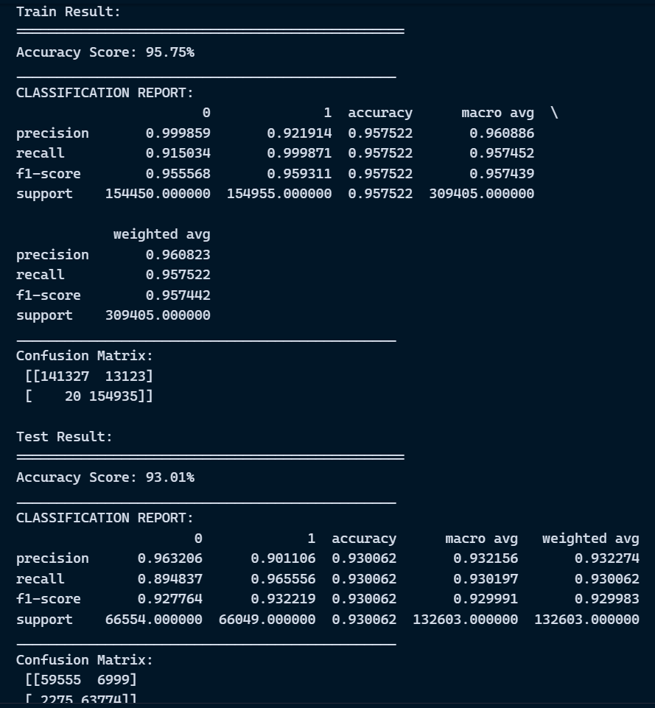

* 1. **Logistic Regression**

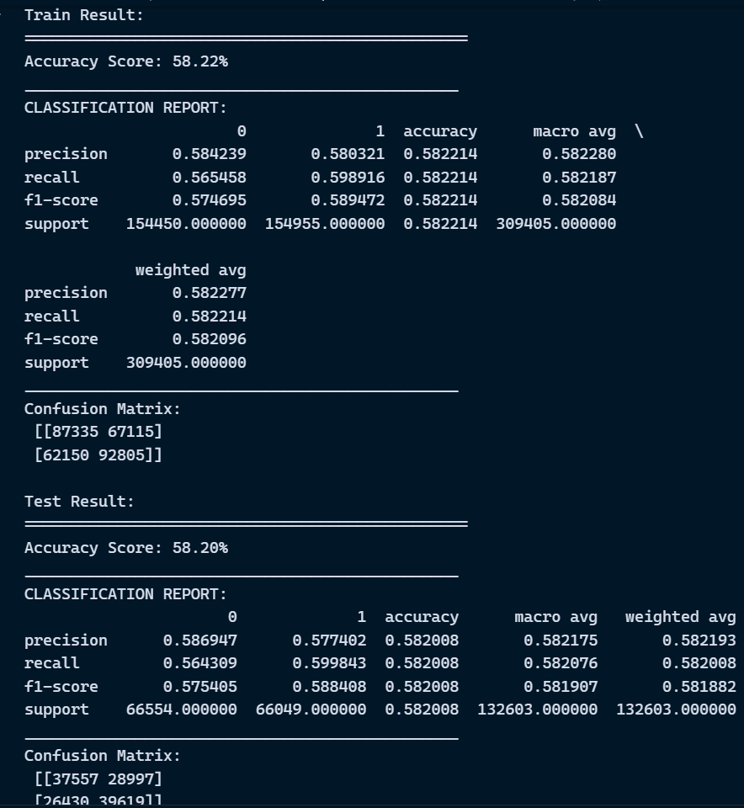

* 1. **Decision Tree Classifier**

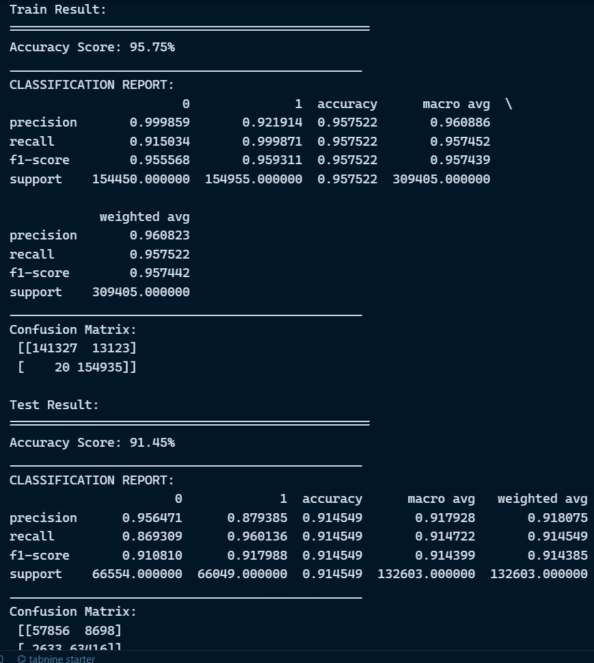

**Results**

* **Target Count of each feature**

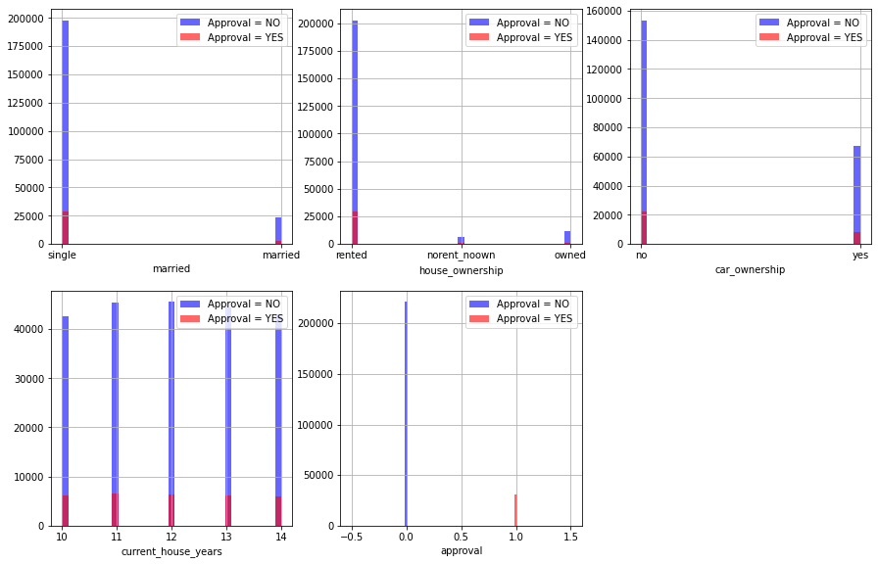

* **Feature Importance with target column**

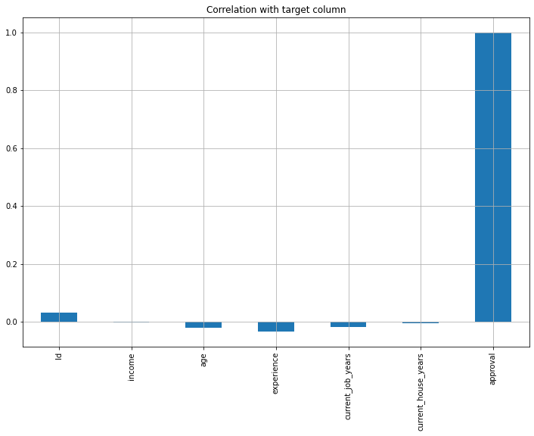

* **Correlation matrix**

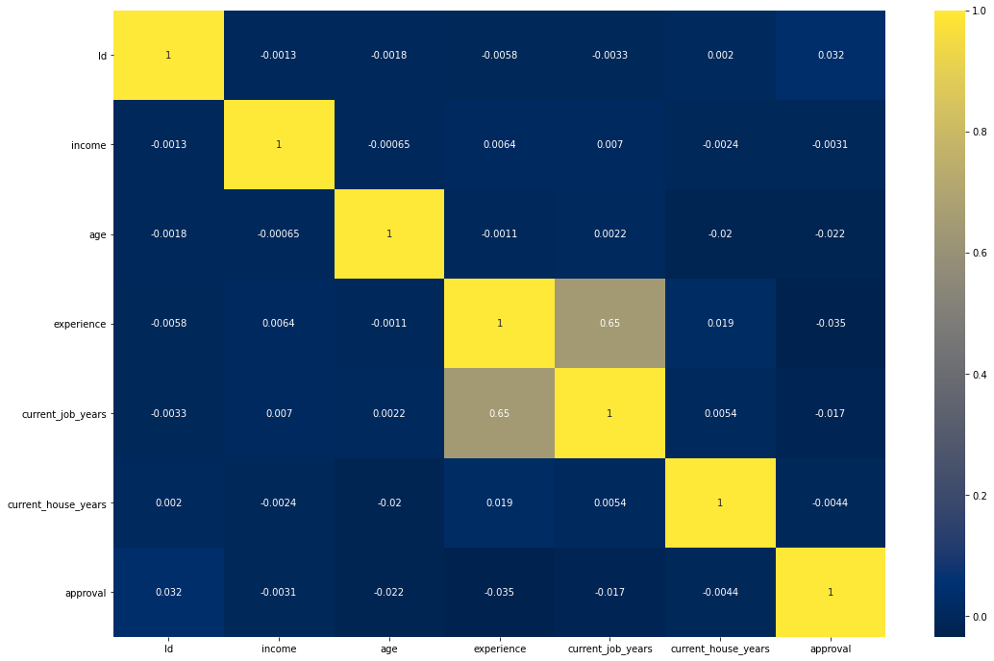

* **Pair Plot**

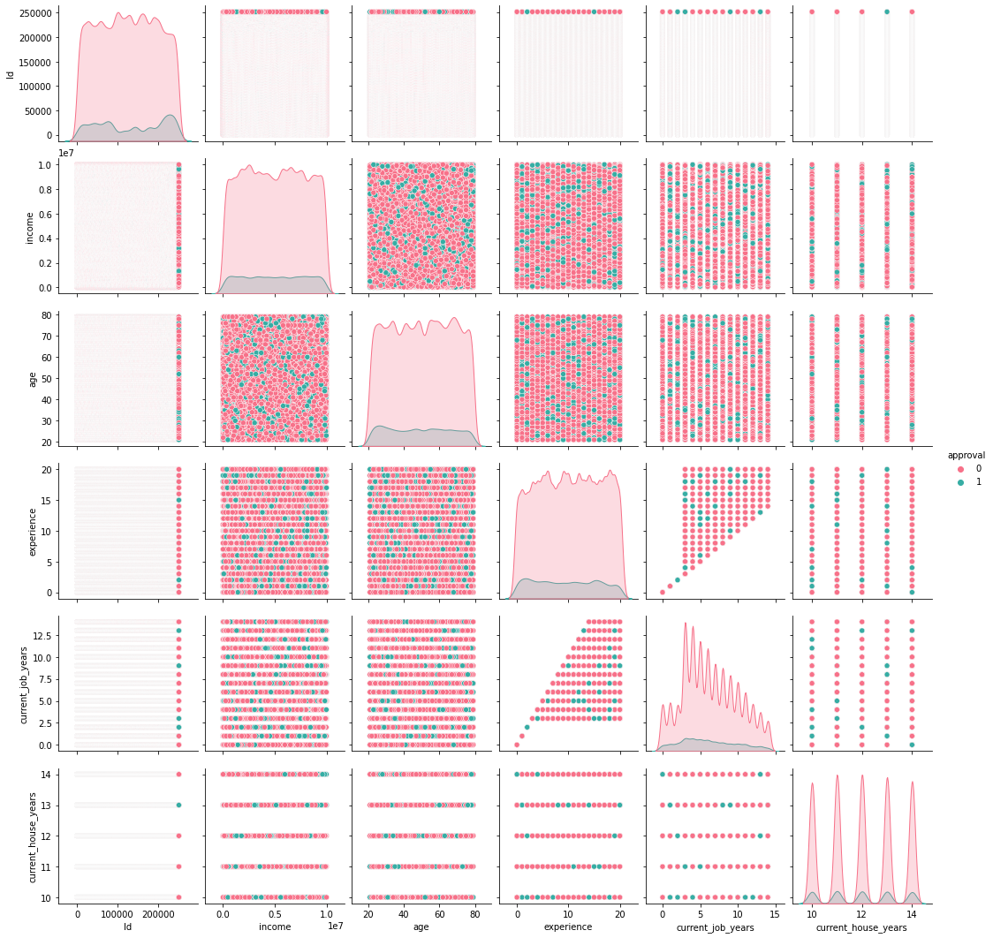

**Conclusion**

As per the main objective of the project is to classify and identify the Credit Card fraudsters and approval of cards for the users based on ML algorithms is being discussed throughout the project. Credit card fraud and approval is most common problem resulting in loss of lot money for people and loss for some banks and credit card company. This project wants to help the peoples from their wealth loss and also for the banked company and trying to develop the model which more efficiently separate the fraud and fraud less transaction by using the time and amount feature in data set given in the Kaggle. we build the model using some machine learning algorithms such as logistic regression, decision tree, Random Forest, these all are supervised machine learning algorithm in machine learning. As part of the future scope, we hope to try out different algorithms to optimize the feature output process, increase the feature similarity of data to improve the model's representation capability.